Day 27 Highlights

1. Reminders
   1. Project five is out – make sure you understand what to do
   2. CS100, CS101 and CS201will be offered during summer on full-term (10 week) schedule.
2. The “struct” construct – three things to know
   1. Use **typedef** to simplify use
   2. Declare a variable of this type - space is created for all fields
   3. Declare a pointer of this type – no space for fields (just ptr)

Need to point to actual space (for example, it can be allocated by **malloc**)

1. Make sure to understands
   1. The difference between a Struct parameter versus pointer to Struct parameter.
   2. The difference between returning a Struct versus returning a pointer to Struct
2. More examples – consider the two structs below

|  |  |
| --- | --- |
| **typedef struct _point {**  **double x;**  **double y;**  **} Point;** | **typedef struct _time {**  **int hour;**  **int minute;**  **} Time;** |

1. Complete the following
   1. Define a line segment using two points
   2. Write a function to read a line segment
   3. Write a function to print a line segment
   4. Write a function to find the length of a line segment
   5. Write a function to find the mid-point of a line segment
2. A more complex structure: define a triangle

|  |  |
| --- | --- |
| **typedef struct _triangle {**  **Point p1;**  **Point p2;**  **Point p3;**  **} Triangle;** | **typedef struct _triangle {**  **Point *p1;**  **Point *p2;**  **Point *p3;**  **} Triangle;** |

* 1. Difference between these two definitions.
  2. Difference between shallow copy and deep copy.

**typedef struct _triangle {**

**Point p1;**

**Point p2;**

**Point p3;**

**} Triangle;**

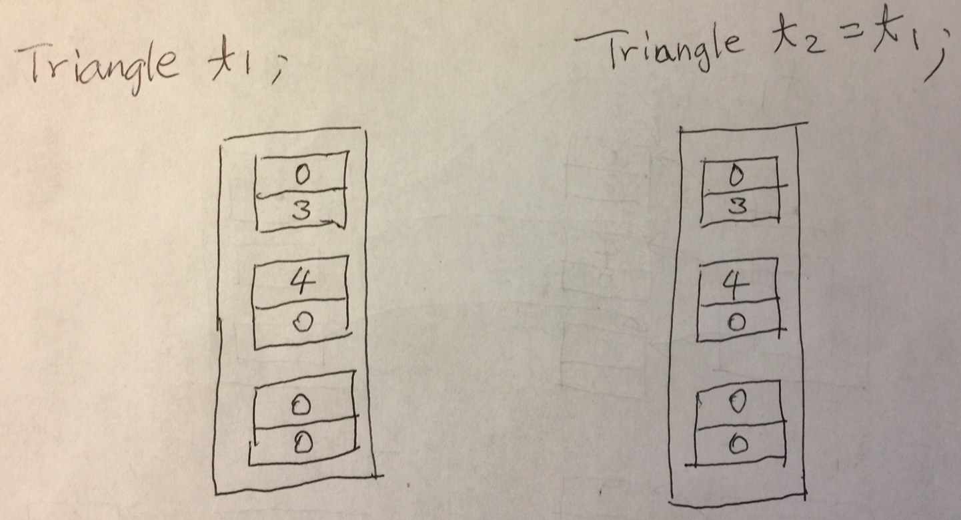

**typedef struct _triangle {**

**Point *p1;**

**Point *p2;**

**Point *p3;**

**} Triangle;**

Shallow copy:

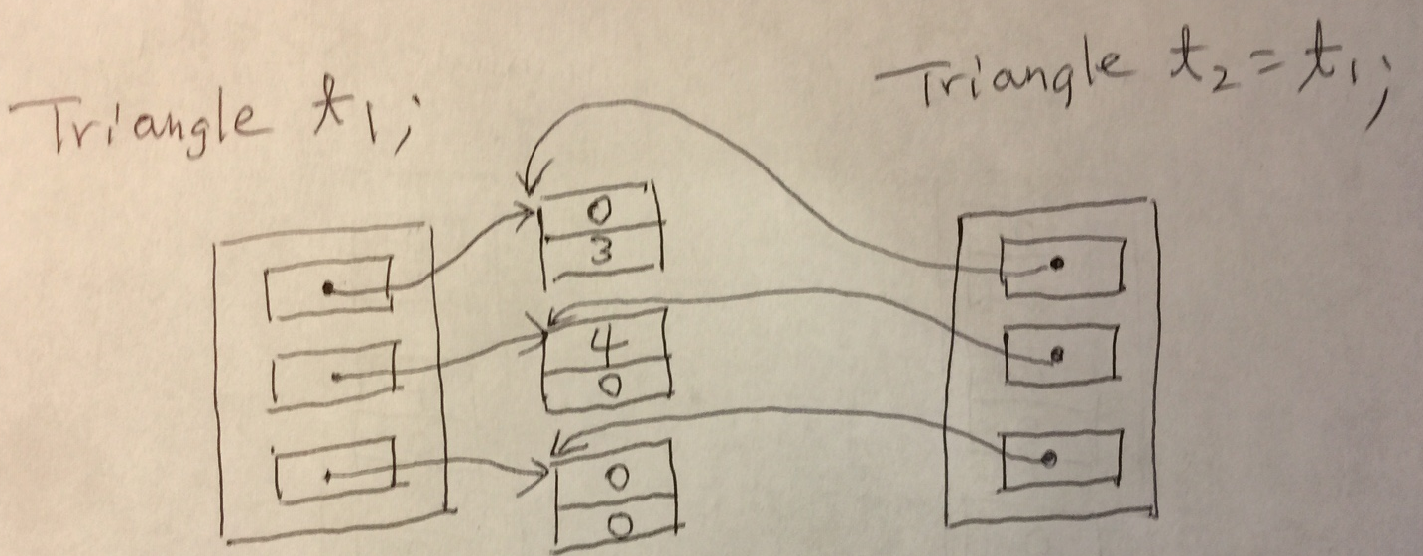

Deep copy:

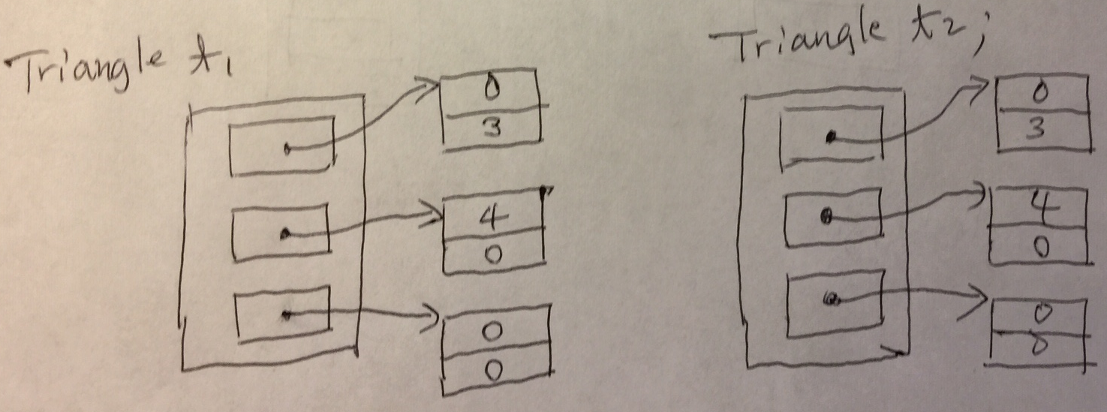

You need to write a function to perform deep copy.

For example, deepCopy(&t1, &t2);